**Analysis of n_neighbors parameter of LOF**

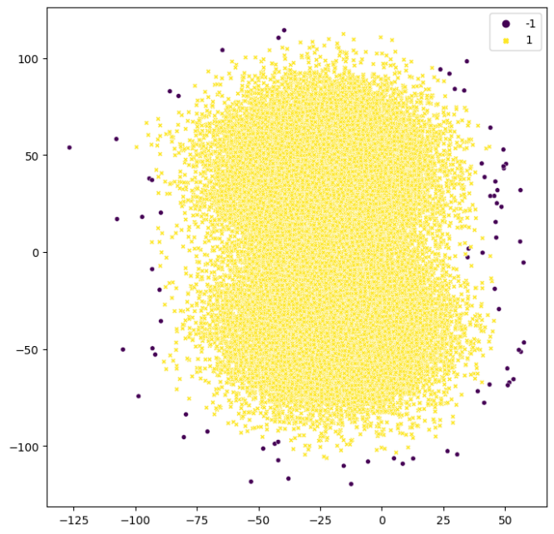 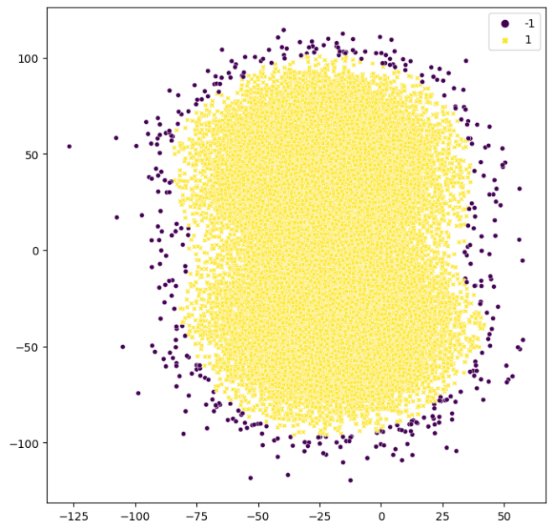

N_neighbors = 20 N_neighbors = 200

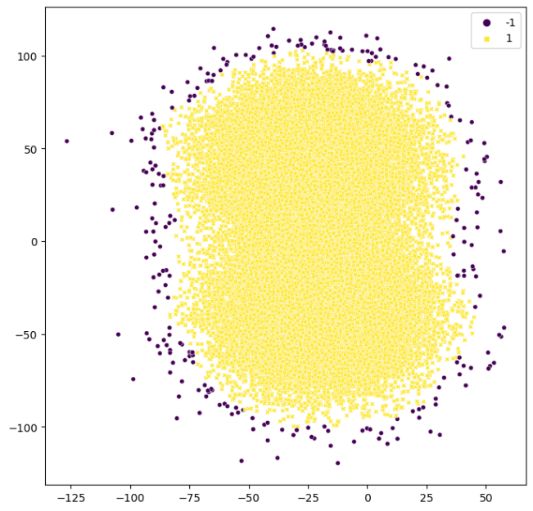 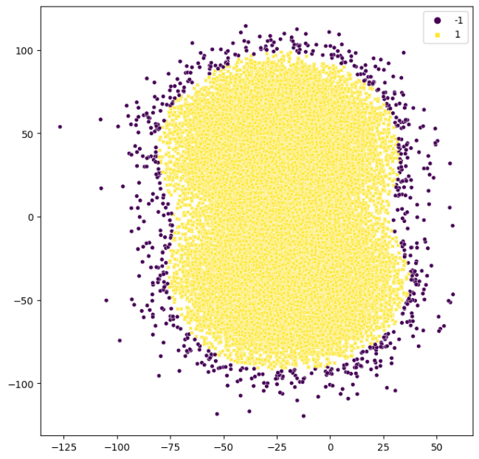

N_neighbors = 100 N_neighbors = 500

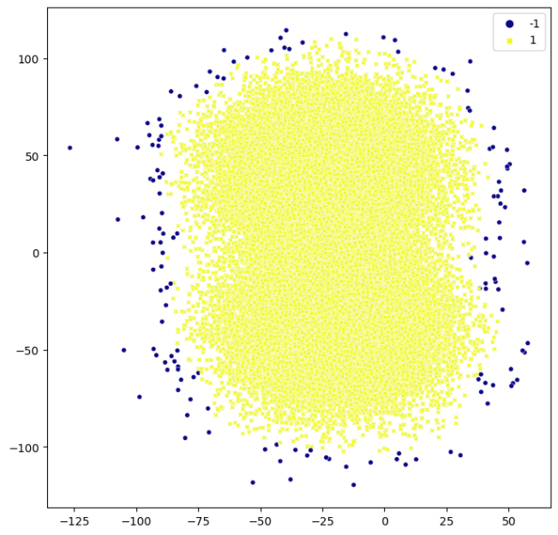 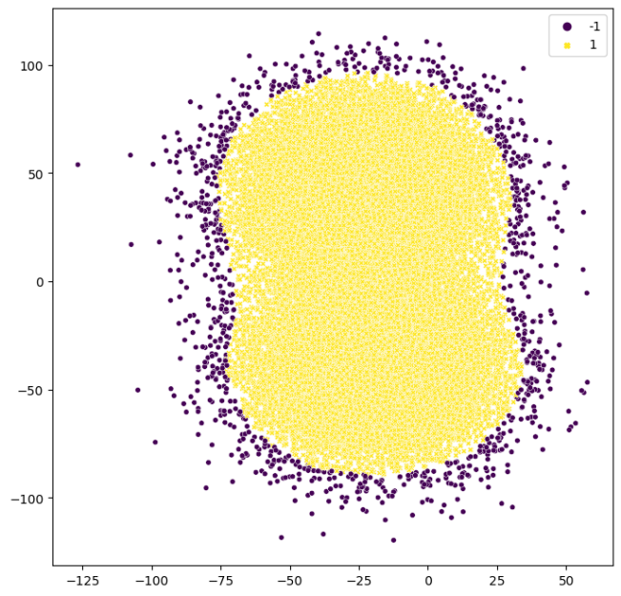

N_neighbors = 50 N_neighbors = 1000

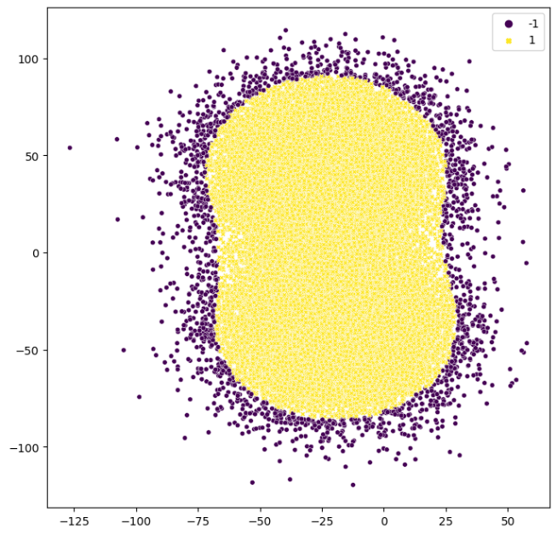

N_neighbors = 5000